*Step 4 : In the src make a “components” folder*

*(NOTE : the folder structure should be like DOM TREE)*

*Utility elements,which are frequently resued in the app such as button keep them in the shared folder)*

*NOTE : component name should compulsory PascalCase*

*NOTE : for every component have a separate CSS & JSX file(recommended) .*

*In the jsx file type “rafce” to create a functional component*

const Navbar = () => {

  return (

    <div>Navbar</div>

  )

}

*In the app.jsx add the component(remember to import the component u add, to import ctrl+spacebar)*

import React from 'react'

import Navbar from './components/navbar/Navbar'

const App = () => {

  return (

    <>

    <Navbar /> //ctrl spacebar and import the Component

    </>

  )

}

*NOTE : to import the component ctrl spacebar + enter*

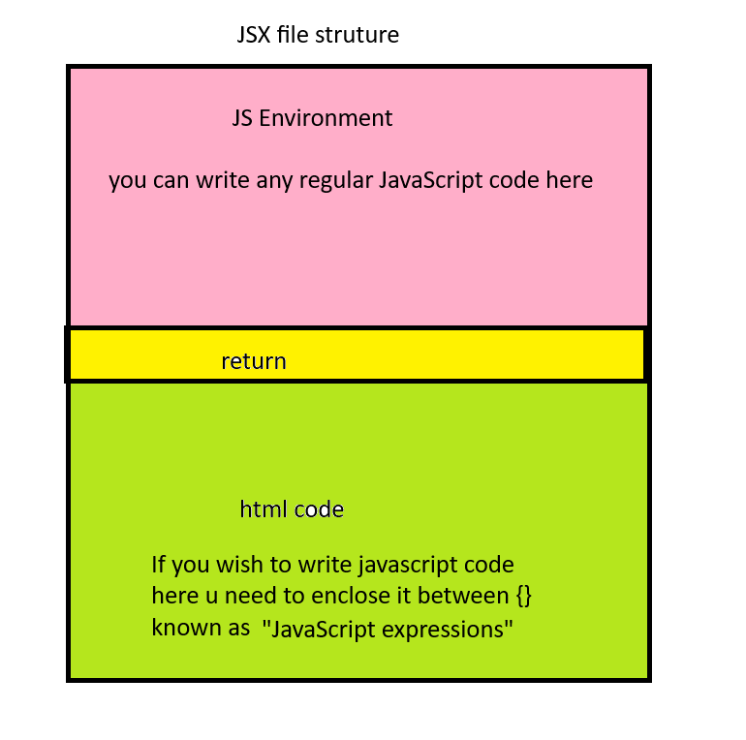

*the js code written in jsx file should be written above the return statement*

*e.g console.log*

*all the manipulation part in the jsx should be done before the return after the return we can only read the values*

Create List Component

const List = () => {

  return (

  <ul>

    <li>A</li>

    <li>B</li>

    <li>C</li>

    <li>D</li>

    <li>E</li>

  </ul>

  )

}

const List = () => {

  const cities=["Delhi","Jaipur","Pune","Mumbai"]

  return (

  <ul>

    {cities.map((city)=>(

       <li>{city}</li>

    ))}

  </ul>

  )

}

1. const List = () => {
2. const cities=["Delhi","Jaipur","Pune","Mumbai"]
3. return (
4. <ul>
5. {cities.map((city)=>{
6. console.log(city)
7. return(<li>{city}</li>)
8. })}
9. </ul>
10. )
11. }

**The return on line 3** is for returning the overall JSX structure (<ul> with <li> items)

The **inner return** **on line 7** is used to return the JSX elements (<li>) for each city in the list.

Conditional rendering

const Message = () => {

const name = “Alice”

if(name)

{

return <h1>Hello {name} </h1>

}

else

{

return <h1>Hello World</h1>

}

const Message = () => {

const name = “”

if(name)

{

return <h1>Hello {name} </h1>

}

else

{

return <h1>Hello World</h1>

}